3. **Dockerized CI/CD Pipeline using Jenkins and Kubernetes**

Step 1: Install Dependencies

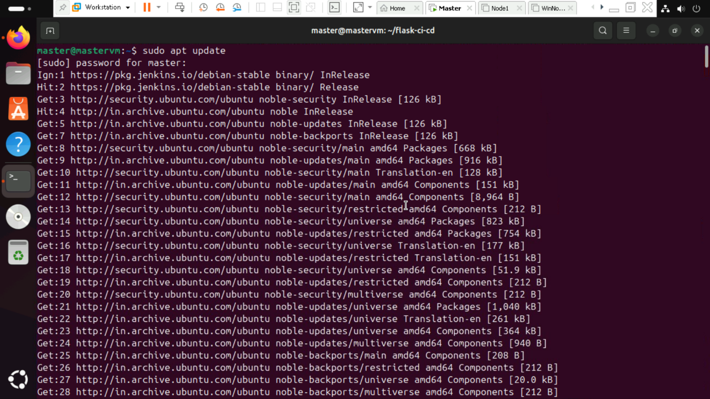

Step 2: Install kubectl

Step 3: Install minikube

Step 4: Start minikube

Step 5: Check status

Step 6: Create app.py file, Docker file, requirements.txt file.

Step 7: Build the docker image.

Step 8: Login to docker.

Step 9: Push the docker image.

Step 10: Connect Kubernetes to Docker and create k8s-deployement. Apply the deployment.

Step 11: Check if the pods are running.

